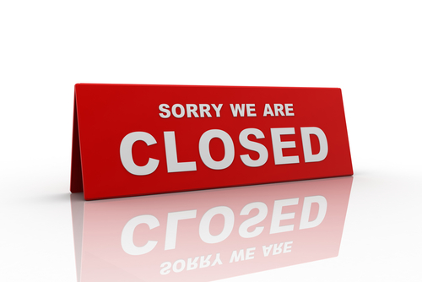
When We Are Closed
The surgery is closed evenings, nights, weekends and bank holidays. We are also closed one afternoon a month for staff training.

Staff Training Days

We will be closed for training the following days from 12:30pm and will reopen the following day at 8.00am:
- Weds 24th April 2024
- Tues 14th May 2024
- Tues 11th June 2024
- Weds 3rd July 2024
- Weds 4th Sept 2024
- Tues 1st Oct 2024
- Weds 6th Nov 2024
- Weds 4th Dec 2024
- Tues 4th Feb 2025
- Tues 4th March 2025

THERE WILL BE NO EVENING SURGERY

Where To Go
If you develop an urgent medical problem which will not wait until the surgery re-opens you can;
- Call 111 to reach the out-of-hours service who may be able to deal with your problem over the telephone. An appointment to see a doctor may be arranged for you.
- Visit a Walk-In Centre. Our nearest centre for minor injuries, strains, sprains, diarrhoea, sickness and contraceptive advice is:

North Kirklees NHS Walk In Centre
Address: Dewsbury & District Hospital, Halifax Road, Dewsbury, West Yorkshire, WF13 4HS

Out-of-hours services are generally busy so please think carefully before asking to see a doctor and only do so if you genuinely cannot wait until the surgery re-opens.

In a genuine emergency you should call 999. Chest pains and / or shortness of breath constitute an emergency.

